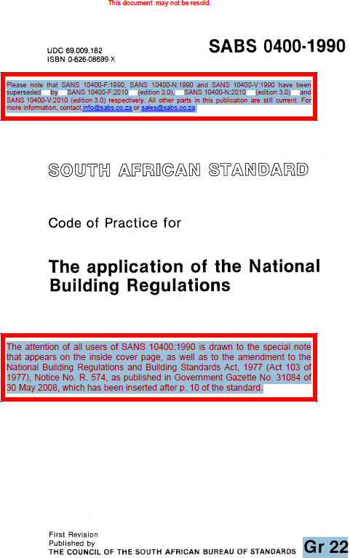

FOUNDATION
Geotechnical Site Investigations

The first step in the home building process is the assessment of the physical properties of soil earth works and foundations of where the house is going to be built.
This process is referred to as the geotechnical investigation and it is carried out by a competent person referred to as a Geotechnical engineer.
Geotechnical investigations are performed by geotechnical engineers or engineering geologists to document the parameters upon which the design of the foundation is to be based.
It is also carried out to assist competent persons in choosing site soil class and in choosing the appropriate foundation solution.
The geotechnical site investigation is also used to
- Evaluate the geology plus the hydrogeology of the site
- To examine geotechnical information pertaining to the site
- And also, to determine the depth of any fill that might be present.
A civil engineer will also inspect the works to ensure that
- There is compliance with the design
- Undertakes responsibility to provide the necessary documentation and overseeing construction
- And instructs the builders on the technical issues
A civil engineer is also regarded as the competent person that should inspect the civil works during the implementation of the solution.
An architecture is the person responsible for all the drawings of the house plans.
Under general circumstances, architectural designs should be drawn on the largest paper size which is denotated with a symbol “A0”.

ENGINEERING FILL DEFINITION & MINIMUM EMPRICAL REQUIREMENTS
Engineering fills are material fills which have been compacted within a defined moisture range, in layers and compacted to a defined density requirement which provides adequate bearing capacity for foundations and slabs.
The fill must be placed in uncompacted layers not exceeding 150mm in respect of compaction by mechanical means.
The upper surface/ finished floor level shall not be less than 150mm above the ground level.
Backfills and beddings should be placed in layers of 150mm thickness by mechanical compaction.
The maximum distance between the backfills and the concrete slabs should be 1 000mm (1 meter) or less.
For a housing unit built whereby the floor level is less than 150mm above the finished surface level, that foundation is referred to as the slab on the ground.
The maximum height of the fill beneath the floor slab and slab on the ground foundation measured at the lowest point shall not exceed 400mm unless of course it has been certified by a competent person.
The fill material shall not contain more than 50% of rock or hard fragments and shall exclude stones and rock fragments of maximum dimensions larger than 150mm.
The minimum founding depth for slab on the ground foundation type should be 300mm. This applies to also strip footings below natural ground level unless founded on rock, in which case, this bare minimum may then be reduced.

SOIL TYPES
The NHBRC classifies soil types for foundations, according to the table below. Based on the soil classification, different types of foundations shall have to be created. For example, areas underlain by weak dolomitic soil condition types must be suitable for a raft foundation and discouraged for a double storey building whereas those underlain by loam & rock type soil, might be suitable for building a single or double storey, with a strip foundation type.
NB. You don’t have to memorize the table below but you have to know how to use it as it is an open book test.

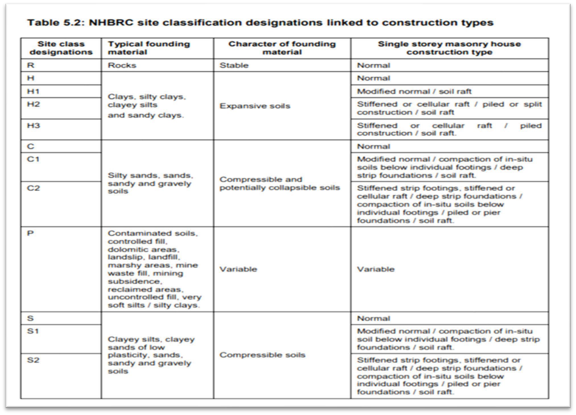

THE DOLOMITIC CONDITION DEFINITION & EMPRICAL RULES

The dolomitic condition refers to areas underlain by sinkholes.
The dolomitic condition is formed when carbon dioxide (CO2) combined with ground water mixes & this results in a weak underground soil structure referred to as a sink hole.
To counter attack foundation areas underlain by dolomitic conditions or sinkholes, a Raft, Mat or Slab on the ground foundation may be used, the NHBRC recommends a minimum depth of 300mm for this type of foundation.
In addition to the above, precautionary measures in addition to those pertaining to the prevention of concentrated ingress of water into the ground are also required.

STRIP FOUNDATIONS DEFINITION & EMPRICAL RULES
Strip foundations also known as strip footings are applied to areas underlain by normal soil type conditions such as loam & rock soil types.
For this reason, they are the most common type in South Africa when it comes to foundation types.
When digging into the ground for the strip foundation, the NHBRC dictates that the minimum foundation depth/trench should be 400mm or deeper.
Steps in these foundations should at least be provided within 1 meter from the corners.
The minimum internal and external widths of the strip foundations shall be 400mm and 500mm respectively for a single storey building with a tiled or sheeted roof in stable soil conditions for the internal and external walls.
However, for a double storey or for a foundation on a load bearing wall, the minimum width should be increased to at least 600mm to accommodate the brick weight for a double storey construction wall.
The thickness, i.e., the minimum slab thickness of the concrete members in a strip footing/foundation shall not be less than 200mm.
The trenches in strip foundations should be set at a maximum gradient of 1:10
Any foundation constructed shall not be used to support any wall forming part of the structural system of any building except where -
(a) such wall is placed centrally on such foundation;
(b) the soil supporting such foundation is not a heaving soil or shrinkable clay or a soil with a collapsible fabric.
Any such foundation shall be constructed in concrete having a compressive strength of not less than 10 MPa at 28 days, or be mixed in proportions by volumes of 1 part of cement, 4 parts of sand and 5 parts of coarse aggregate.
Any continuous strip foundation shall have a thickness of not less than 200 mm: Provided that where the foundation is laid on solid rock such thickness shall not apply.
The width of any continuous strip foundation shall be not less than -
(a) 600 mm in the case of a foundation to a load-bearing or free-standing masonry wall or to a timber framed wall supporting a roof with Class B or a double storey
(b) 400 mm in the case of a foundation to a non-load-bearing Internal masonry wall or to a timber framed wall supporting a roof with Class A or Class C or for a single storey home.
Where any strip foundation is laid at more than one level the higher portion of the foundation shall extend over the lower portion for a distance at least equal to the thickness of the foundation.
Any void between the top of the lower portion of such foundation and the underside of the higher portion shall be completely filled with concrete of the same strength as that required for such foundation.
Where any concrete floor slab is thickened to form a foundation -
the thickness, including that of such floor slab, shall be not less than that required for a continuous strip foundation; and the width of the thickened portion below such floor slab shall be not less than that required for a continuous-strip foundation: Provided that such thickening shall not be required under non-load-bearing timber-framed walls.
Where any pier is built into or forms part of any wall the thickness of the foundation to such pier shall be the same as that required for such wall. The length and width of the foundation to such pier shall be such as to project by 200 mm at any point on the perimeter of such pier.
The thickness of the foundation to any sleeper pier or sleeper wall shall be not less than 150 mm. The length or width of the foundation to such sleeper pier shall be not less than 450 mm. .
The width of the foundation to such sleeper wall shall not be less than 300 mm.
These masonry walls must not overhang the concrete slabs of raft foundations by more than 20mm.
The masonry units may NOT be laid on edge as a means by which the lower course of foundation masonry may be brought up to level.

EMPRICAL RULES FOR CONCRETE MIXING & PREPARATION
Normally cement is delivered in bags of 50kg with a volume of approximately 33 litres when packed under air pressure at the factory.
The bags of cement should be stacked at a height not exceeding 12 bags to avoid decompression.
Usually, a standard builder’s wheelbarrow, filled to the top, has a volume of 65 litres (0,065 cu m, which is almost double the volume of a sack).
When batching by volume, it is then safe to assume that one wheel barrow load is equivalent to two sacks of cement.
When mixing concrete, drinking (potable) water is the quality of water that should be used in mixing the concrete.

The following ratios are recommended by the NHBRC for the mixing for the two different types of concrete stones.
For a 19mm stone, the following ratios shall be used.
- 2 bags of cement, 2 wheelbarrows of sand, 2 wheelbarrows of stone & 20 Litres of water should be mixed.
For a 13mm stone (class 32,5) stone for 10MPa
- 2 bags of cement (100kg), 4,5 wheelbarrows of sand, 3 wheelbarrows of stone & 66 Litres of water should be used.
As with the above ratios, the strength of concrete mixes in the above can be increased by
- Decreasing the water/concrete ratio.
- Decreasing the amount of void in concrete by upgrading the concrete.
- Curing the concrete well, curing methods include plastic sheeting as well as water curing.
Once mixed, care should be put in to avoid the mixed concrete from losing too much moisture by ponding of the surface with water or covering with sand or mat, or covering concrete with water proofing or plastic sheeting.
The concrete should be compacted thoroughly to eliminate bubble and void as well as to sustain a level surface.
It should also be of such a workability that it can be readily compacted into the corners of the framework and around reinforcement without segregation of the materials or excessive bleeding of free water at the surface.
A slump test should be carried out on the concrete properties on site to determine its workability.
Honeycombing is the term used to describe areas of the surface that are coarse and stony in a concrete mix. It may be caused by insufficient fine material in the mix, perhaps due to incorrect aggregate grading or poor mixing, congested reinforcement, poor vibration or poor placement.
Before casting concrete reinforcements should be clean of rust layers as well as oil paint.

STRENGTHS OF CONCRETES IN FOUNDATIONS
Compressive strength in concretes refers to the ability of a certain structural material or structural element to withstand loads. This is measured in a unit called Mega Pascals.
The minimum strength of concrete on an unreinforced foundation on a single storey home should be 15Mpa. The strength of concrete should not be less than 25MPa on the lower level of a reinforced double storey building. On unreinforced or reinforced slabs, the concrete shall be of a strength of 30MPa, this empirical rule also applies to other reinforced concrete members & precast items such as flagstones.

COMPRESSIVE STRENGTHS OF CONCRETE & MORTAR

Generally, the compressive strength gained by any concrete member after 28 days with respect to any grade is regarded to be 99%. In rules set out for the lower storey in double storey buildings, the average compressive strength of the hollow masonry units should not be less than 3.0 MPa, whereas for the solid masonry units, these should not be less than 7.0 MPa. Basic uncomplicated foundations should be constructed with concrete that has a compressive strength of at least 10MPa at 28 days in the ratio 1:4:5 of cement, sand and stone.

The minimum required compressive strengths of class 11 mortar at 28 days is 14.5 MPa. All mortar utilised within construction must be used within 2 hours after mixing, otherwise, it will harden making it unsuitable for construction.
Mortar in which the initial set has occurred (i.e., thumb print hard) cannot be used at all.

PLASTER

Sand-cement plaster is used extensively in building work as a decorative or protective coating for concrete, masonry walls and concrete ceilings. Aspects dealt with include the selection of material, surface preparation and plaster application.

The table below shows the prescribed mix proportions for plaster adapted from SANS 2001.

Just like in Mortar, cement plaster must be mixed and applied within 2 hours, otherwise, it must be discarded.

The following are the common defects & their causes found in plaster.

- Grinning – It is when positions of the mortar joints are clearly visible through the plaster. This is caused by different rates of suction between the mortar and the bricks. The solution is to apply plaster undercoat or spatter dash coat before plastering

- Debonding – Plaster not staying on the wall after hardening or in its dry state. This is caused by dust on the wall when plastering, over rich mixes, very thick layer of plaster greater than 15mm.

- Lack of hardness – Plaster is easily chipped away or easily scrapped off when its hardening – This is caused by plastering in full sun and wind, addition of extra water after mixing. Obviously, the solution to this problem is to avoid the above.

Plaster thickness should be between 10-15 mm and as uniform as possible. The more accurate the substrate, the easier it is to meet these requirements. Note that, if plaster is applied in a single coat, thickness should be 10mm to 15mm. A single coat should not be thicker than 15 mm. Plaster should be used within two hours of being mixed and never be re-tempered by adding additional water or cement.
Plaster can be applied to masonry and concrete surfaces, not exceeding 22mm for masonry units and 16mm in concrete surfaces.

UNDER-FLOOR MEMBRANES IN FLOOR CONSTRUCTIONS.

An underfloor membrane as well as an under-tile membrane, when properly laid, it provides a highly effective impermeable barrier against the ingree of wind driven rain and dust, for this reason, it is therefore provided on all tiles and slated roofs irrespective of the slope and if ceilings are not installed.

The purpose of an underfloor tile membrane, especially in timber structures is to
- Serve as bracing for floor joists
- Serve as a noise dampener
- And most importantly, to provide a vapour barrier to prevent moisture from coming in

Any under-floor membrane shall not be less than 0,25 mm thick and shall be laid on a surface which shall not contain any sharp object which may perforate such membrane.

Such membrane shall be turned up around the perimeter of and at least for the full thickness of any slab. Any joint in such membrane shall overlap by not less than 150 mm and shall be effectively sealed.

WOODEN FLOORS

For laminated wood flooring, floor underlays provide a “vapour barrier” to prevent moisture from coming through the floor of the home and then migrating into the flooring; the underlayment may also have noise-dampening properties.

The underside of any floor boards other than those laid on a concrete slab shall not be less than 550 mm above the surface of the ground immediately below such floor boards.

In wooden flooring, end matched joints should be at a minimum of 150mm apart from the end matched joint in the previous line of flooring, however 200mm – 250mm is better.

One doesn’t want to create a pattern in a strip floor as patterns are normally kept for parquet block floors where a specific pattern is the design of the floor for e.g. - herringbone, brick pattern, block pattern etc.

The minimum length should at least be 1 meter. As wood barely moves at all in the length expansions in the length need only be around 5 - 10mm total (Irrespective of the length) so that when the floor expands in the width the flooring board ends can slide along the wall without getting jammed.

As engineered boards are more stable than solid the minimum of 3mm per L/m can be left more acceptably however again, if there is space try leave the maximum as no one wants to go back to a job to put the floor down if it can be avoided.

One of the most important reasons to use underlayment is to protect your hardwood floor against moisture damage.

You can often find underlayment with an added vapour barrier which helps to keep your wood floors safe from water damage and moisture intake from the ground below.

On suspended timber floors, the minimum clearance between a greed and a joist should be 1000 (1 Metre).

The minimum height above ground level for timber floor joists should be 150mm.

FLOOR CONSTRUCTION
Any floor supported on ground or on filling shall be constructed of -
impervious floor units not less than 40 mm thick and consisting of slate, bricks, natural stone or other approved material; or a concrete slab which shall have a compressive strength of not less than 10 MPa at 28 days, or be mixed in the proportions by volume of 1 part cement, 4 parts sand and 5 parts coarse aggregate, and the thickness of such slab shall be not less than 75 mm.
Such filling material shall -
  - consist of suitable material; and
  - be applied in well compacted layers not more than 150 mm in thickness.

Any water-resistant floor shall be constructed of concrete or other approved material. The underside of any floor boards other than those laid on a concrete slab shall be not less than 550 mm above the surface of the ground immediately below such floor boards.

CAVITY/HOLLOW WALL CONSTRUCTION

A cavity or hollow wall is a wall consisting of two separate walls, built side by side, with a gap of at least 50mm and not more than 110mm and tied to each other via galvanized wall ties.

The purpose of a cavity wall is to ensure that the inner leaf of the wall remains dry and that no moisture penetrates to the inside of the building.

Cavity walls are popular in coastal areas within a radius of 30km. They are used to prevent dampness to the inner walls as a result of the high humidity content.

The cavity size should be in between 4cm to 10cm & the internal and external leaves should have at least 10 mm thickness.

The cavity between masonry walls may be between 50-110mm in thickness, but no thermal advantage is obtained by increasing cavities beyond this.

Masonry walling specifies a distribution of not exceeding 450mm vertical centres/spacing and horizontal spacing of 600mm irrespective of the cavity thickness.

The wall tie distribution of one per 2.5m2 (50mm cavities) greater the 3.0 wall-ties per square meter (70mm cavities) but the requirement is now 3.7 ties per square meter.

In a cavity wall, the strength of infill concrete in the first course should at least be 10MPa.

Weepholes within the cavity wall should be spaced horizontally at a maximum spacing of not more than 1 000mm (1,0 Metres).

The external walls of buildings located in areas of prolonged heavy rain, wind driven rain and or where condensation is high, shall be of a cavity wall construction.
The NHBRC requires that bricks must have a minimum thickness of a brick force of 2,8mm.
In hollow bricks used for cavity wall foundations, the grading of mortar should be 3.0 MPa & 10.0 MPa.
The space in between hollow bricks should not be filled with anything if the objective is to separate the outside environmental factors such as coldness or heat from the inside wall, however, in cases whereby the masonry is required to spread concentrated loads, then those cavities or hollow spaces can be filled with mortar, concrete, grout or rebar & other reinforcements to meet the specific objectives.
Where Clay bricks are used in the home building process, those bricks must be wetted before placement, furthermore, clay bricks must never be mixed with cement bricks because they expand and contract at extremely different rates which can lead to a cracking of the masonry wall unit.

TOOTHING IN MASONRY WALLS

Toothing in masonry refers to the process of leaving alternating openings (teeth) for an adjoining block or brick wall to be started from. This allows the adjoining wall to be started without having to adjust or cut brick.

The toothing process is also sometimes used when a window or door opening is to be cut into an existing masonry wall. For this process, the opening is cut and removed, a lintel installed, alternating bricks removed, and half/partial bricks are cut to be inserted back into the teeth to make the jamb flush for installing the window or door.

VERTICAL & HORIZONTAL CHASES IN WALLS

A chase in home construction is a vertical or horizontal space dug in a wall, to provide an area for conduit pipes or wires to run through. Builders strategically place chases to ensure that cables run together. A chase may run up the wall from the basement to the attic or the upper part of your home.
Vertical Chases

Vertical chases should not be dug deeper than a third of the wall thickness –

With a standard 100mm bricks and blocks, that’s going to be 33mm maximum, which is quite deep anyway – that’s not allowing for any plaster coating which could be 10mm so the maximum depth then works out at 36mm from the front face of the plaster.

Horizontal Chases

Horizontal chases are even restricted more thus not allowing a dig, one sixth of the wall thickness - with standard 100mm blocks, that’s going to be 16mm which is usually quite sufficient – that’s not allowing for any plaster coating.

Chases on opposite sides of the wall should never be in line, i.e., ‘back-to-back’ as this would weaken the structural strength of the wall.

NON-LOAD & LOAD BEARING WALLS

A load-bearing wall or structural wall, refers to a wall that bears the weight of the house from top to bottom.

This wall helps disperse the building's weight from the roof down to the foundation, and its removal could cause the entire structure to collapse.

The minimum bearing of concrete floors on load bearing walls should therefore be set at a width of 90mm. For a non-load bearing wall, the minimum slab thickness should be 200mm. To consistently control and monitor the levelness of masonry construction, one will make use of a spirit level.

The masonry/brick walling shall not overhang concrete foundation slabs by more than 20mm.

The masonry brick walls shall not be laid when the temperature is less than 5 degrees Celsius as this might solidify the water within the mortar thus preventing it from settling properly & thus creating a solid bond.

LINTELS

A lintel is a structural horizontal block that spans the space or opening between two vertical supports. It is often found over doors and windows.

Care should be taken when handling or transporting lintels, especially the longer lengths.

They are easily damaged by untrained or negligent forklift drivers.

Longer lengths should always be supported in at least 3 places and preferably transported and stored on their side until used.

Lintels must always be laid with the hollow side uppermost, and never upside down. Lintels should be laid singly or side by side depending on the thickness of the walls.

The biggest mistakes made by most builders when building in lintels are not using a sufficient number of support props and not leaving the support props in place for enough days.

Please follow the guidelines below.

General length of lintel support/span | 1.5M | (1.5M - 2.5M) | 2.5M
*Bearing on each side, minimum | 150mm | 250mm | 350mm
Brick courses above lintel, minimum | 4 | 4 | 5
Support/props every x Metres | 1M | 1.5M | 1.5M
*Days support required  *(Ref: NHBRC Part 3, Sec 3 Feb 1999 Rev No.1) | 7days | 7days | 7days

Type of Formwork | Formwork Removal Time
Sides of Walls, Columns and Vertical faces of beam | 24 hours to 48 hours (as per engineer’s decision)
Slabs (props left under) | 3 days
Beam soffits (props left under) Garages | 7 days
Removal of Props of Slabs:
i) Slabs spanning up to 4.5m | 14 days
ii) Slabs spanning over 4.5m | 14 days
Removal of props for beams and arches

Lintels – Formwork Stripping Times
Table – 2: Formwork Stripping Time (When Ordinary Cement is used):

i) Span up to 6m | 14 days
ii) Span over 6m | 21 days

PERPEND, MORTAR & BEDDING JOINTS

The name given to a horizontal mortar joint is referred to as a bedding joint whereas the name given to a vertical mortar joint is known as a perpend joint.

As a general rule, all Mortar, Bed and perpend joints should not be less than 5mm or greater than 20mm.

The thickness of the first bed joint above a supporting element (foundation, slab or lintel) should not be less than 5mm or more than 35mm.

Laying and bedding of masonry units shall be of the type and class required in terms of the scope of work.

Hollow brick units shall be laid with the thicker shell uppermost and shall be shell bedded, horizontally and vertically.

The face shells of the bed joints shall be fully filled with mortar.

Perpend joints shall be mortared for a distance from each face at least equal to the face shell thickness of the unit.

The webs shall be fully buttered in all courses of piers and columns, in the first course above a supporting element and on either side of cores, which are reinforced.

Each unit shall be laid and adjusted to its final position while the mortar is still plastic.

Any unit which is disturbed to the extent that the initial bond is broken after initial positioning, shall be removed and re-laid in fresh mortar.

All collar joints in multi leaf walls shall have a nominal thickness that does not exceed 20 mm and shall be solidly filled with mortar as the work proceeds.

All protrusions of mortar that extend more than 15 mm into cores or cavities, and which are to be filled with infill concrete, shall be removed.

All perpend and bed joints shall have a nominal thickness of 10 mm. The bed joint thickness shall not be less than 5 mm or greater than 15 mm; perpend joint thickness shall not be less than 5 mm or greater than 20 mm.

The thickness of the first bed joint above a supporting element shall not be less than 5 mm or greater than 30 mm.

The maximum bed joint thickness of the first bed joint be not less than 5 mm or greater than 35, might require the use of grade 10 infill concrete to raise the surface of the supporting member to enable a bed joint of the specified thickness to be achieved.

Mortar droppings which fall on face masonry units shall be removed as soon as possible. Bricks that have frogs shall be laid with the frog or the larger frog uppermost.

Frogs shall be filled with mortar as the work proceeds. The perforations in a low-density brick shall be filled with mortar where the masonry is required to spread concentrated loads, such as at bearings to lintels and beams.

In burnt clay masonry units, control joints shall generally be provided at minimum intervals of 6M wide. The maximum vertical control joint spacing permitted by SANS 10145 for control joints where reinforcing is 200mm is 9 metres.

The permissible deviation (PD) for perpend or first bed joint thickness in housing units is between -5 + 10mm.

The cavities of hollow blocks shall be filled completely with concrete, grout, or mortar where the masonry is required to spread concentrated loads, such as at bearings to lintels and beams.

DRAIN PIPES
A drain is the primary vessel or conduit for unwanted water or waste liquids to be flashed away, either to a more useful area, funnelled into a receptacle, or run into sewers or stormwater mains as waste discharge to be released or processed.
Drain pipes must have a minimum soil cover over the outside of the drain pipes of at least 300mm if no concrete is laid above the drain however, if there is a concrete or cast in situ concrete laid over the drain pipe, then this requirement can be reduced to 100mm.
Concrete anchor blocks shall be provided if the drain pipes are of a UPVC plastic.
Where a water pipe is to be laid underground horizontally next to a sewer or other service, it should at least be laid 3 metres away from the drain to avoid mixing of water.
The minimum distance between drain pipes laid underground horizontally parallel to a pipe conveying water intended for general household should be 1 500mm (1.5 metres) apart.
When a drinking water pipe crosses a sewer, then the minimum clearance should be set at 600mm (0.6 metres).
Service trenches shall also not be excavated parallel to buildings within 1 500mm (1.5 metres).

STRUCTURAL DIMENSIONS – ROOM AREA & HEIGHT DIMENSIONS
The NHBRC specifies minimum room area & height dimensions that certain areas within a house should meet as follows.
The minimum area for the whole floor area of a habitable dwelling cannot be less than 30 square metres. Therefore, no house will be approved by the NHBRC if it is less than 30 square metres.
The minimum area for a habitable/living room other than a kitchen, scullery or laundry, should at least be 6 square metres with a minimum height clearance of 2.4 metres.
The minimum for a bedroom/sleeping area should at least be 1.8 metres in height.

STRUCTURAL DIMENSIONS – WINDOWS & DOOR FRAMES
The NHBRC also specifies minimum structural dimension for other structural components such as doors and window frames & these are as follows.
The nominal height of masonry above window openings where roof trusses are supported should not be less than 400mm.
The external sills of the window should be slopped towards, the lugs for door and window frames shall extend approximately 250mm into the masonry walls.
The steel door frames and built-in window frame surrounds shall have a minimum thickness of not less than 1mm.

A beam filling i.e., a brick between the roof timber situated from wall plate to roof covering must be used to prevent the entry of birds into the house.

STAIR CASE DIMENSIONS
Stair cases shall be constructed with a minimum width of 250mm and a minimum of 170mm to a maximum of 200mm in terms of risers.
A minimum head space above a stair case measured vertically from the pitch line to the ceiling should be 2 100mm (2,1 metres).
The minimum height of any balustrades and parapet walls to flat roof top with no restriction of access should at least be 1 Meter.

DAMP PROOF COURSE (DPC)
A damp-proof course, commonly referred to as a DPC, is the first layer of brick laid over a damp-proof membrane as a moisture barrier applied to foundations to prevent moisture rising into brickwork.
The importance of a damp proof course is to prevent rising damp through the walls.
A strip of approved damp proof course material of 150mm wide should be placed lengthwise under the ridge tiles, overlapping the top course of tiling on each side by 25mm.
Lapped ends must be supported underneath and the overlap should not be less than 150mm.
All horizontal damp proof courses shall protrude 40mm from the external face of the wall.
Galvanized wire or stainless steel of grade 816 wall ties must be used in damp areas or in coastal areas of 30km radius preferably with a cavity wall.
Wall ties as well as mortar can also be used to join walls at an intersection.
Rebar reinforcements which can be used in walls & foundations normally have a rating of “Y10” whereby the 10 stands for a 10mm diameter whereas the y stands for a high yield reinforcement.
The minimum wire diameter of butterfly type wall ties should be 2,8mm.
Damp proof courses have to be used in cavity walls all the time to assist with moisture control.
The only exception to using a damp proof course, is either when the roof overhangs by more than 750mm or if the distance between the top of the window frame & the wall plate is less than 700mm.
If an electrical conduit pipe is to be fitted through a damp proof course material, then the openings must be sealed with a self-adhesive tape.
If reinforced wires (rebar)/ wire mesh is placed within concrete, nothing can be used to cover those wires though.
An apron is another feature which can be built around the house to assist in surrounding drains with ease.

TIMBER STRUCTURES IN THE HOME BUILDING PROCESS
The term timber logging is used to refer to the process of cutting, skidding and processing trees to produce timber and pulp to supply the world’s markets for construction and other products such as for use in roofing & other general construction purposes such as wooden floors etc.
There are 3 key facets when it comes to timber construction, and these include
- Timber treatment
- Timber grades
- Good carpentry practices
For example, a timber roof truss is a wooden structural framework of timbers designed to bridge the space above a room and to provide support for a roof.
All timber used for construction must be graded. Ungraded timber or timber without a grade mark nor a certification can never be used for construction or later on considered structural.
All timber must be treated by a certification body approved by the South African National Standards (SANS) and the application of chemicals must at least penetrate the timber at a depth of at least 20mm.
The table below actually does classify and dictates where different timber grading structures can be applied. It progresses from the least humid conditions, i.e., for example, timber grading used for ceilings should not be exposed to any water or moist conditions and these are denotated from H0-1 whereas to the sea, it is denotated H6.
Therefore, it can be assumed that the “H” symbol stands for environmental Humidity content that the timber structure is exposed to.
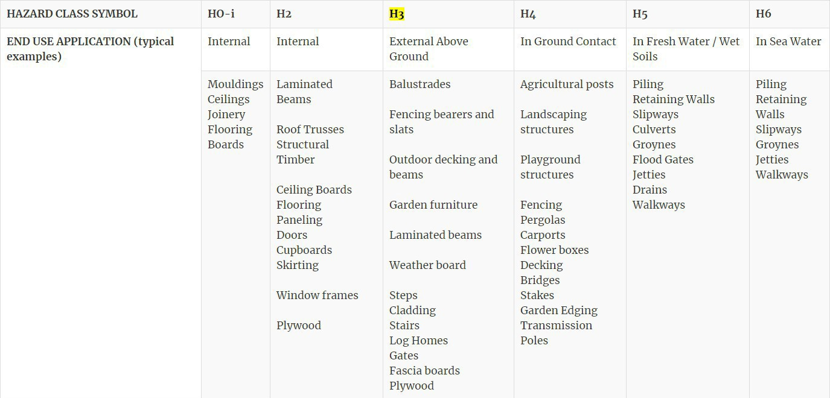

ROOFING
A roof is the top covering of a building including all materials and constructions necessary to support it on the walls of the building or on uprights, providing protection against the elements such as rain, wind & extremes of temperatures.
As can be seen in the diagram below, a roof is made of a timber structural framework collectively known as trusses.
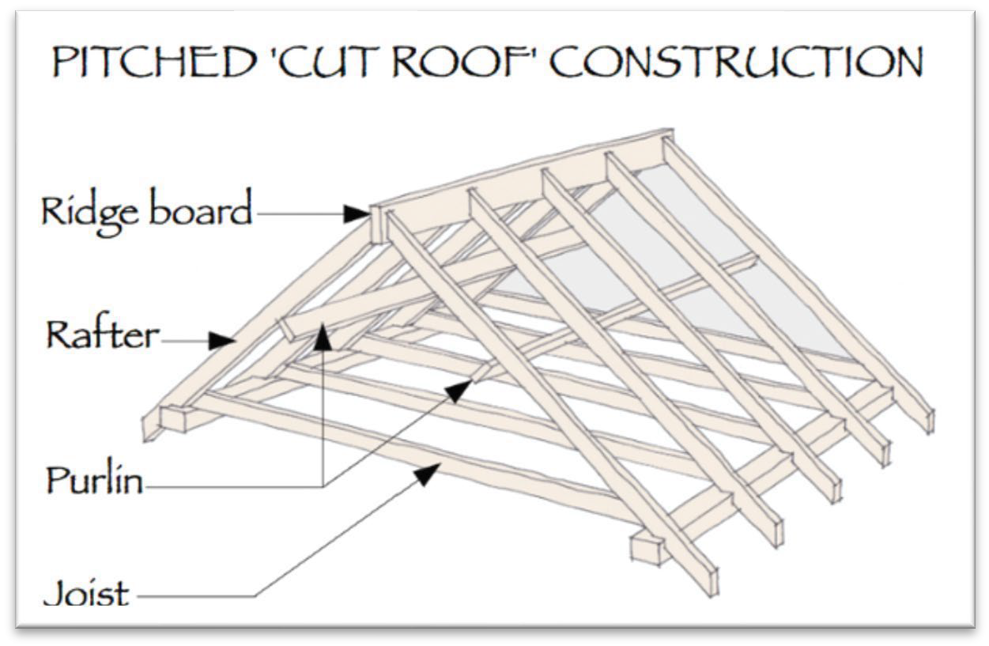
The names given to the individual components making up a truss are summarized below.
The name given to a horizontal member attached to an unplaced material perpendicular to a rafter in order to support the roof sheeting is known as a purlin whereas the vertical one is known as the rafter.
The upper most part of the roof structure is referred to as the ridge board whereas the joist is placed below, under to provide a sheeting apparatus.
All vertical elements within the structure are referred to as a stud (thou none are provided in the diagram above).
The roof must be supported by flashing gutters to help prevent damage to the house by shedding off or draining excess rain water away from the walls of the house.
The flashing gutters must have a minimum width of 300mm & a minimum length 150mm. The flashing gutters should also be placed at alternate flutes at 75mm.
Purlins and rafter splices should not be put within 1,5 Metres from the gable ends.
Down pipes, if provided, shall discharge into concrete lined drainage channels, which discharge the water at least 1,5 metres away from the building in dolomitic areas designated as D2 & D3 (See NHBRC soil type classification table discussed before).
When building a house with a heavy roof type, the minimum anchor embedment for a heavy roof type should be at least 300mm. The minimum angle or slope for concrete and clay roof titles should be 17 degrees to allow for the easy flow of water. A flatter degree angle would not be conducive as it would be difficult for the water to run off the slope.
Any roof trusses attached shall be tied down to the supporting walls and columns by means of galvanized steel straps or galvanized steel wires that are built into the wall.

Drips in concrete roofs must be inserted underneath the underlayment at all rakes and above of the underlayment in eaves.
The drips on the concrete roofs must be provided at roof overhangs at 12mm depth.
Roofs must be installed with waterproofing in mind and a specialist water proofing contractor shall provide a home owner with a 12 months water proofing guarantee.

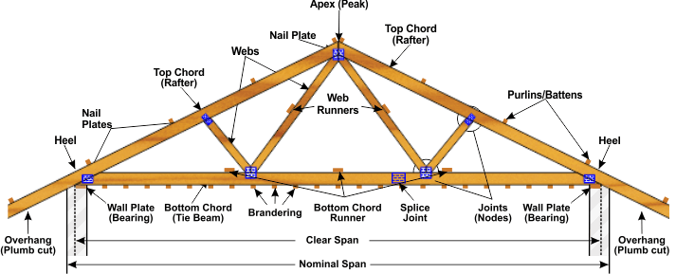

The correct size of branderings applied must be of the dimensions of 38 x 38.
The minimum dimensions of a wall plate supporting the tie beam and rafters must also be of the dimensions of 38 x 114 x 76mm.
The minimum size of temporary timber bracing for trusses is 76 x 36mm.
The minimum size of purlins supporting sheeting materials is 76mm x 50mm.
The trusses, rafters and purlin beams shall be supported on wall plates of minimum 38mm x 76mm or similar flat bearing surfaces which are levelled and positioned so as to ensure that the ends of such members are vertically aligned.
The wall plate level must have a minimum height of 2 600 from the floor slab.
In a single storey building of masonry construction, the span of the roof trusses/rafter between the supporting walls should not exceed 10 metres otherwise, the roof structure might end up caving in.
The minimum anchor (Roof ties) embedment to masonry for heavy roofs should be 20mm.
The thickness for galvanized roof sheeting shall not be less than 0,5mm.

BRACING
In construction, bracing refers to a system of diagonal intersecting support structures that are used to reinforce building structures in order to overcome lateral loads.
It consists of devices that clamp parts of a structure together in order to strengthen or support it.
Cross bracing is usually seen with two diagonal supports placed in an X-shaped manner.
Under lateral force one brace will be under tension while the other is being compressed.
Below is a list of clamps of acceptable methods for bracing a timber frame in terms of the South African Bureau of Standards
- A solid timber brace
- A metal angle
- A flat metal brace
Sheathing refers to the board or panel material used in floor, wall or roof assemblies of both residential and commercial construction.
The most basic function of sheathing, in any application, is to form a surface onto which other materials can be applied.
There are several types of sheathing, each having a specific function based on its application.
Below is an example of materials which can be used for sheathing
- OSB (Oriental Standard Board)
- Hard Board (Engineered Timber)
- Ply wood

GENERAL
The final stage in the NHBRC registration process is the enrolment of the house that is going to be built.
This will ensure that the NHBRC registers & documents the municipal approved plans, the construction contracts, the project cost breakdown as well as the title deed amongst other things.
Once an enrolment certificate has been issued, it cannot be cancelled at the occupation date.
All assessments to the home building process are applied using the South African National Standards however, in instances where the national standard is missing, Agrement south Africa is applied.

